**Matrices** @ Chris Kheng

**Symmetric:** A = AT

**Theorem 2.2.22** Let A be an m x n matrix.

1. (**A**T)T = **A** 2. If **B** is a m xn matrix, then (**A+B**)T = **A**T + **B**T

3. If a is a scalar, (a**A**)T = aAT. 4. If **B** is an n x p matrix, then (**AB**)T = **B**T**A**T

**Definition 2.3.11**

1. A0 = I

2. A- n = (A-1)n = A-1 A-1… A-1(multiply itself by n times)

**Remark 2.4.4**

1. All elementary matrices are invertible and their inverse are also elementary matrices.

Let A be a **m** xn matrix. Then the elementary matrix E is a square matrix of **order m.**

**Inverse of elementary marices**

1. Interchanging 2 rows: E-1 = E

2. Multiplying a row by constant / adding the multiple of 1 row to another

~ If k is in the diagonal, change it to 1 / k (multiplying a row)

~ If k is not in the diagonal, change it to -k (adding 1 row to another)

**Determinants**

1. det( I ) = 1 2. det(A) = det(AT)

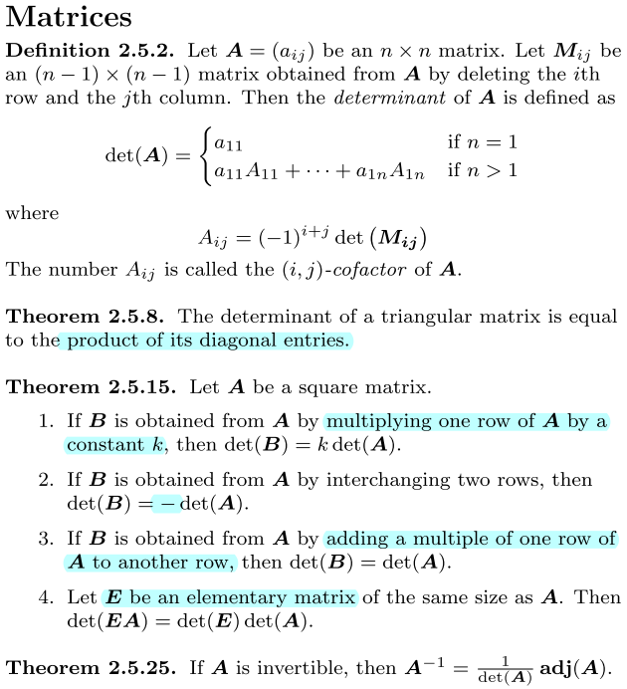

**Theorem 2.5.22**

Let A and B be two square matrices of order n and a be a scalar.

1. det(a**A**) = an det(**A**)

2. det(**AB**) = det(**A**)det(**B**)

3. If A is invertible, then det(**A**-1) = 1 / det(**A**)



**Def** **2.5.24** Let **A** be a square matrix of order n. Then the adjoint of **A** is the n x n matrix

adj(A) = (Aij)**T**n x n , where Aij is (i,j)-cofactor of A

**Theorem 2.5.27** Suppose **Ax = b** is a linear system where **A** is an n x n matrix. Let **Ai** be the matrix obtained from **A** by replacing the ith column of **A** by **b**. If **A** is invertible, then the system ahs only one solution

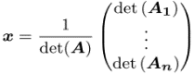

**Euclidean Space**

**Discussion 3.2.5**: If V = {**u1**, …, **uk**} spans Rn, then for any vector v in Rn, the system c1u1 +…+ckuk = v is always consistent.

**Theorem 3.2.9** If V is a subspace, then the following must be true

1. **0** is in span(S)

2. For any v1, v2, vr in span(S) and c1,c2,c3 in R

c1v1 + c2v2 + … + crvr is in span(S)

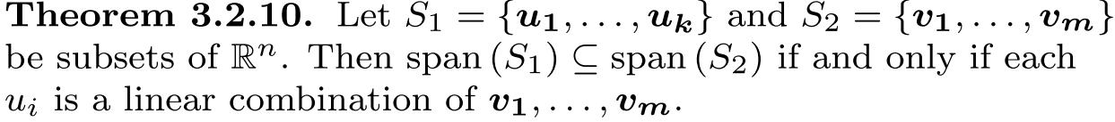

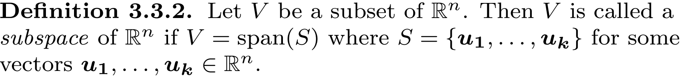

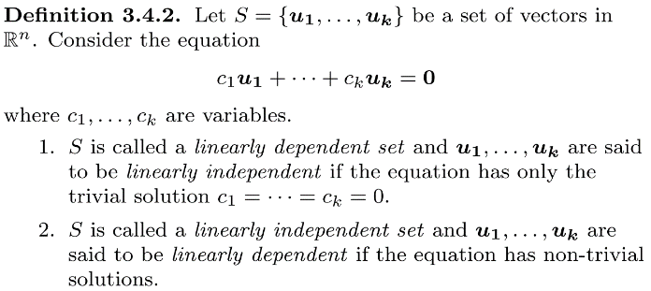

1. If the system has **only** **trivial** solution, then u1, … uk are **linearly independent**

2. If the system has **non-trivial** solution, then u1, … uk are **linearly dependent**

**Theorem 3.5.7** Let S be a basis {**u1**, …**uk**}for a vector space V. Every vector in V can be expressed in the form v = c1u1 + … + ckuk in **exactly one way**

**Coordinates Vector**

**Remark 3.5.10**: Let S be basis for a vector space V.



2. For any v1, …, vr ∈ V and c1, … , cr ∈ **R**

(c1v1 + c2v2 + … + crvr)s = c1(v1)s + c2(v2)s + … + cr(vr)s

**Theorem 3.5.11:** Let S be a basis for a vector space V where |S| = k

Let v1, v2, …, vr be vectors in V. Then (LI = linearly independent)

1. v1, v2, …, vr is LI iff (v1)s, (v2)s, … (vr)s is LI

2. span{v1, v2, …, vr} = V iff span{(v1)s, (v2)s, … (vr)s = **R**k

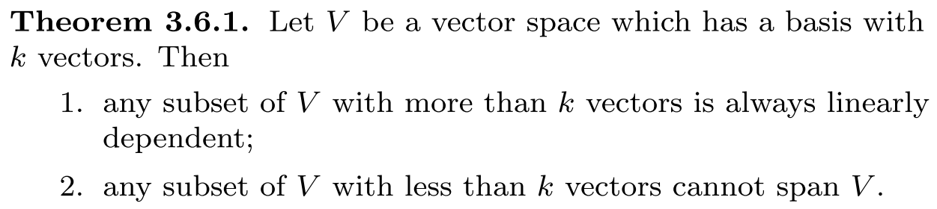

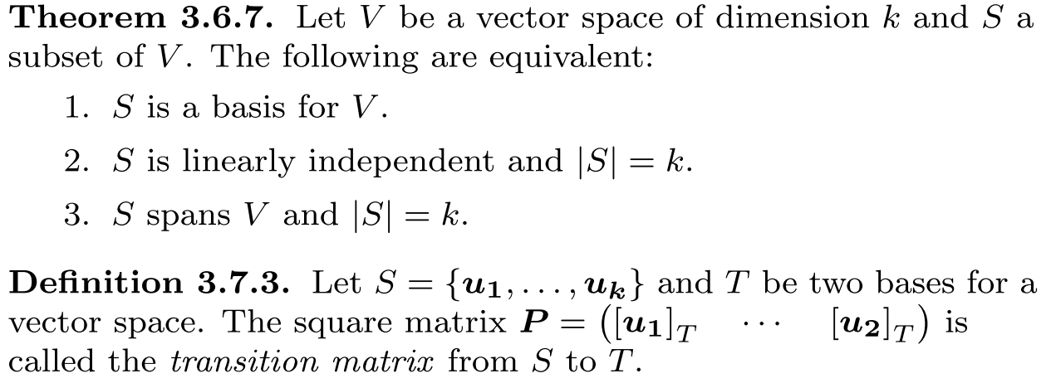

**Theorem 3.6.9:** Let U be a vector space and U a subspace of V

Then dim(U) ≤ dim(V).

If U ≠ V, then dim(U) < V

**Definition 3.7.3:** Let S = {**u1**, …, **uk**} and T be two bases for a vector space. The square matrix **P** = ([**u1**]T … [**uk**]T) is called the **transition matrix** from S to T

**Theorem 3.7.5:** Let S and T be two bases of a vector space and let **P** be the transition matrix from S to T.

1. P is invertible 2. P-1 is the transition matrix from T to S

**Vector Space of Matrices**

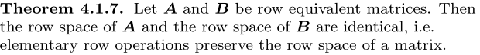

**Theorem 4.1.11** Let **A** and **B** be row equivalent matrices.

1. A given set of columns of A is LI iff the set of corresponding columns of B is

LI.

2. A given set of columns of A forms a basis for the column space of A iff the set

Of corresponding columns of B forms a basis for the column space of B

**Remark 4.1.9** Let **A** be a matrix and **R** be ref of A. Then the set of non-zero rows in R forms a basis for the **row space** of A.

**Remark 4.1.13** The basis for the **column space** of A can be obtained by taking the columns of A that corresponds to the pivot columns in R.

**Basis extension theorem**

Let S be a LI set where |S| < n. To extend S to become a basis for **R**n, put all the vectors of S into a matrix in **row form**. Reduce the matrix to ref.

For each non-pivot column, get a vector whereby all of the entries are zero except the entry corresponds to the index of the non-pivot column (let that entry in the vector be 1). The vectors that you get for each non-pivot column are the vectors that you need to add to extend S to become a basis for **R**n.



**Def 4.2.3** The rank of a matrix **A** is the dimension of its row space (or column space). Rank(**A**) is equal to the # of nonzero rows as well as the # of pivot columns in ref of **A.**

**Remark 4.2.5** Let **A** be an m x n matrix.

1. rank(**A**) ≤ min{m, n} 2. If A is **full rank**, then rank(**A**) = min{m, n}

3. rank(**A**) = rank(**A**T) 4. row space of A = column space of AT

# A **square** matrix A is of **full rank** iff det(A) ≠ 0 (only applies to square matrix)

**Remark 4.2.6**  A linear system **Ax = b** is consistent iff A and the augmented matrix (**A** | **b**) have the same rank.

**Theorem 4.2.8** Let **A** and **B** be m x n and n x p matrices respectively.

Rank(**AB**) ≤ min{rank(**A**), rank(**B**)}

**Def 4.3.1** If **A** is an m x n matrix, then nullity(**A**) ≤ n since the nullspace is a subspace of Rn.

**Theorem 4.3.4** Let **A** be a matrix with **n columns.** Rank(A) + nullity(A) = n

**Theorem 4.3.6** Suppose **Ax = b** has a solution **v**. Then the solution set of the system is S = {**u** + **v** | **u** is an element of the nullspace of **A**}, i.e. the general solution of **Ax** = **b** can be written as **x** = (the general solution of **Ax** = **0**) + (one particular solution of **Ax** = **b**).

**Orthogonality (From here onwards, V refers to a subspace of Rn.)**

**Orthogonal:** dot product is 0

**Def 5.1.2** The distance between **u** and **v** is ||**u** – **v**||

**Remark 5.1.3** If **both** u and v are row vectors : **u . v**  = **uvT**

column vectors: **u . v = uTv**

**Theorem 5.1.5** (a is a scalar)

1. **u . v**  = **v** **. u** 3. (a**u**) **. v** = **u .** (a**v**) = a(**u . v**)

2. (**u** + **v**) **. w** = **u . w** + **v . w** 4. ||a**u**|| = |a| ||**u**||

**w .** (**u** + **v**) = **w . u** + **w . v** 5. **u . u** ≥ 0 {**u . u** = 0 iff **u** = **0**}

**Remark 5.2.6** To check if a set S of non-zero vectors in a vector space V of dimension k is the **orthogonal**/**orthonomal basis** of V, we just have to check:

i) S is orthogonal / orthonormal; and ii) |S| = k

(cuz orthogonal implies LI)

**Theorem 5.2.8** If S = {**u1,** …, **uk**} is an orthogonal basis for a vector space V, then for any vector **w** in V,

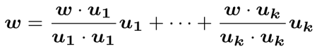 

**Def 5.2.10** A vector **u** in Rn is orthogonal to the vector space V if **u** is orthogonal to **all vectors in V**.

**Def 5.2.13** Every vector u in Rn can be written **uniquely** as **u** = **n** + **p** such that **n** is a vector orthogonal to the vector space V and **p** is a vector in V. **p** is the projection of **u** onto V and the **p** of every vector is **unique**.

**p** is also known as the **best approximation** of u in v.

**Theorem 5.2.15** Let **w** be a vector in Rn. If {**u1**, …, **u­k**} is an **orthogonal** **basis** for the vector space V, then the projection of **w** onto V is

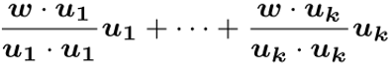

**Theorem 5.2.19** Let S = {**u1**, …, **u­k**} be a basis for a vector space V. The following is the Gram-Schmidt Process which convert S into an orthogonal basis.



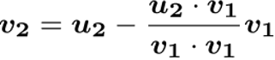 ... 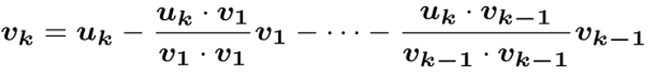

Note the RHS of each ui is a projection of ui­ onto a vector space

**Def 5.3.6 A** is an m x n matrix. A vector **u** in Rn is the least squares solution **to Ax = b** iff ||**b – Au**|| ≤ ||**b – Av**|| for all **v** in Rn.

**Theorem 5.3.8** Let **p** be the projection of **b** onto the column space of **A**.

**u** is a **least square solution** to **Ax = b** iff **Au** = **p**

**Theorem 5.3.10 u** is a least squares solution to **Ax** = **b** iff **u** is a solution to

**A**T**Ax** = **ATb**.

**Def 5.4.3** A square matrix **A** is orthogonal if **A**-1 = **A**T

**Theorem 5.4.6** Let **A** be a square matrix of order n. The following are equivalent:

1. **A** is orthogonal 3. The columns of **A** form an orthonormal basis for Rn.

2. The rows of **A** form an orthonormal basis for Rn

**Theorem 5.4.7** Let S and T be two **orthonormal bases** for a vector space.

Then the transition matrix **P** from S to T is orthogonal, i.e. **P**T is the transition matrix from T to S

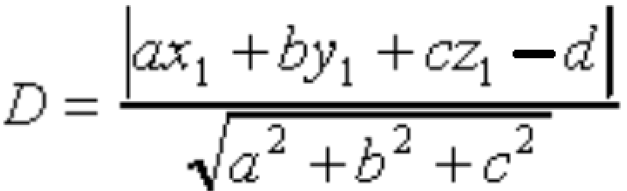 Distance between a point (x, y, z) and a plane ax + by + cz = d

**Eigenvalues and Eigenvectors**

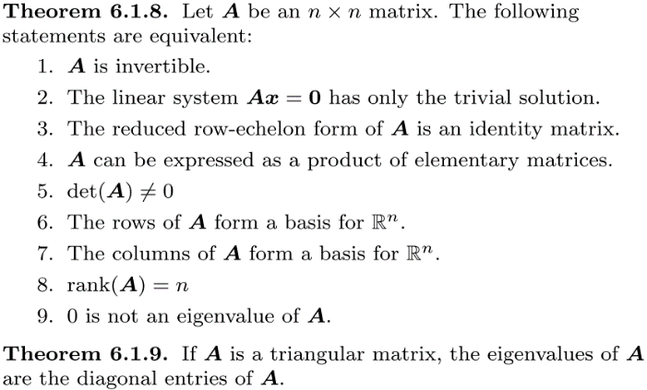

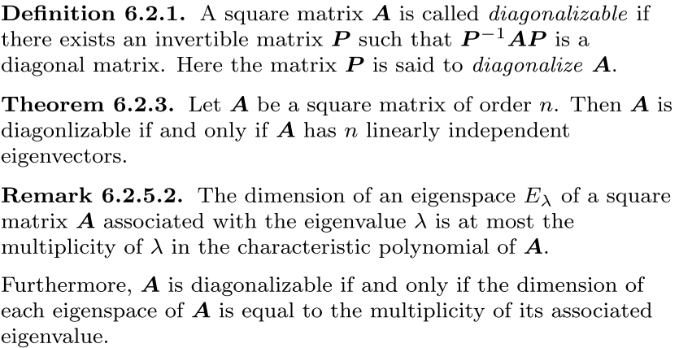

**Theorem6.2.7** Let **A** be a square matrix of order n. If **A** has n distinct eigenvalues, then **A** is diagonalizable. However, the **converse** of this statement is **not true**, i.e. a diagonalisable matrix of order n may not need to have n distinct eigenvalues.

**Discussion 6.2.10.1** Let **A** be a square matrix of order n and **P** an invertible matrix

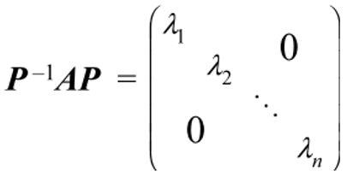 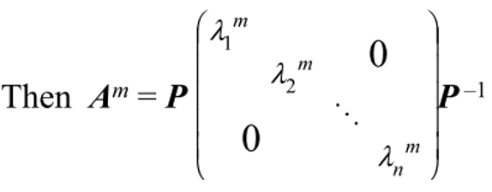

If **A** is invertible, then:

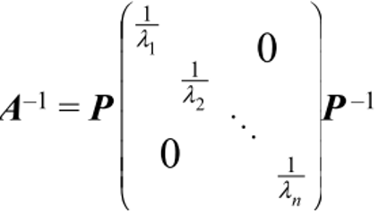

**Def** **6.3.2** A square matrix **A** is orthogonally diagonalisable if there exists an orthogonal matrix **P** s.t. **P**T**AP** is a diagonal matrix.

**Theorem 6.3.4** A square matrix is orthogonally diagonalisable iff it is symmetric.

**Algorithm 6.3.5** To obtain the set of orthonormal vectors in the orthogonal matrix P, simply apply Gram-Schmidt process to convert the set of vectors you obtained using algorithm 6.2.4 into a set of orthogonal vectors, then normalise them to obtain a set of orthonormal vectors.

**Algorithm 6.2.4** To obtain the set of vectors in the matrix P, find all the eigenvalues of A by solving the characteristic equation det(λ**I** – **A**) = 0, then find the basis for each eigenspace. Then put all the vectors in each basis into a set S, where S is (**u1**…**uk**) If |S| = n, then A is diagonalisable and P = (**u1** … **uk**). In the diagonal matrix D, the position of each eigenvalue in the diagonal corresponds to the position of its eigenvector in P.

**Linear Transformation (From here onwards, let T be linear transformation from Rn to Rm)**

**Def 6.1.3**. The first matrix on the RHS below is the **standard matrix**.

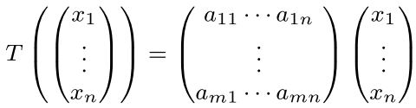

If n = m, then T is a **linear operator** on Rn.

**Theorem 7.1.4** If T is linear transformation, then the following **must be true**

1. T(**0**) = **0** 2. T(c1**u1** + c2**u2** … + ck**uk**) = c1T(**u**1) + c2T(**u2**) … + ckT(**uk**)

To come out of a formula for T, first find a basis for Rn. Then by doing gaussian elimination, find a general formula to express any vector **x** in Rn as a linear combination of all the vectors in the basis (the formula is for the coefficients). Then, write T(x) = c1T(**u1**) + … + ckT(**uk**), where each ci can be obtained from the general formula, then apply T to every vector **ui** (vectors in the basis) and then expand and simplify the RHS and you will get the formula for T

**Discussion 7.1.8** Let {**e1, e2**, …,**en**} be the standard basis for Rn. The standard matrix A for the linear transformation T is **A** = (T(**e1**) T(**e2**) … T(**en**)).

T(**ei**) = **Aei** = the i-th column of **A**

**Definition 7.1.10** Let S: Rn → Rm and T: Rm → Rk be linear transformations. The composition of T with S, i.e. **T o S**, is a mapping from Rn → Rk. **T o S is again a linear transformation**. (T o S)(u) = T(S(u))

If **A** and **B** are the standard matrices for S and T respectively, then the standard matrix for T o S is **BA**.

